Email Scraper Results and Notes:

Figure 1: Search for Glassdoor using Search Bar
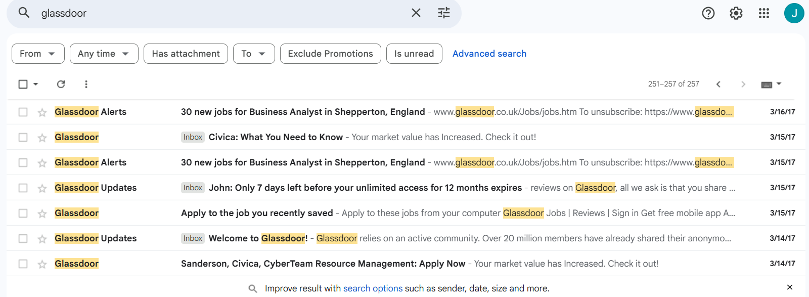

Figure 2: UI Set Up
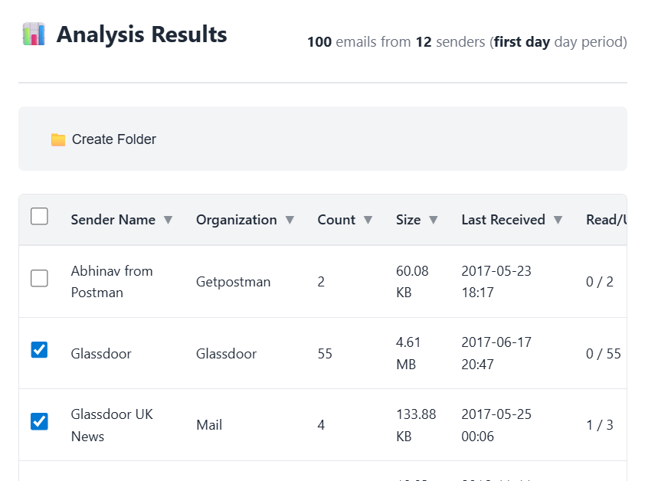

Figure 3: UI Create Folder, accept Default Name
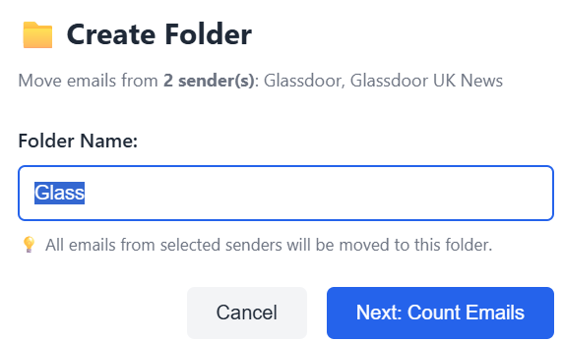

Figure 4: Initiation of Create_Folder
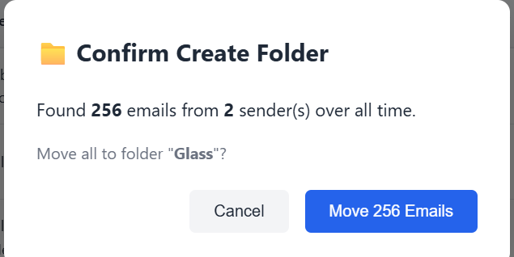

Figure 5: Progress Tracking (static, but informative).
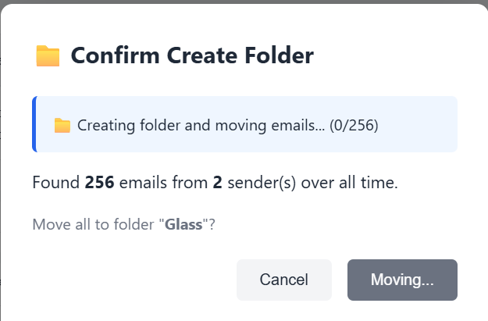

Figure 6: Completion confirmation message
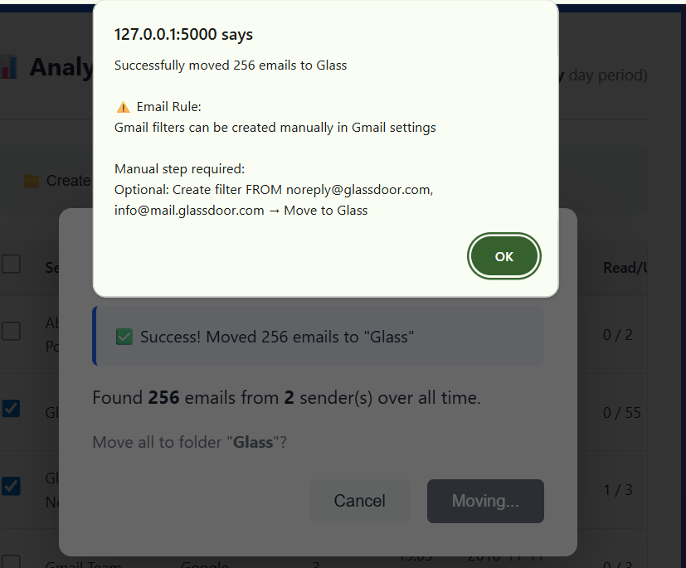
Audit Trail in Debug: 239 + 17 = 256.
127.0.0.1 - - [26/Dec/2025 17:43:09] "GET /static/style.css HTTP/1.1" 304 -
DEBUG: Counting emails from 2 senders
DEBUG: Using Gmail API for counting emails
DEBUG: Searching for messages from: noreply@glassdoor.com
DEBUG: Found 239 messages from noreply@glassdoor.com
DEBUG: Searching for messages from: info@mail.glassdoor.com
DEBUG: Found 17 messages from info@mail.glassdoor.com
DEBUG: Total emails from all senders: 256
127.0.0.1 - - [26/Dec/2025 17:47:50] "POST /action/count-emails HTTP/1.1" 200 -
DEBUG: Create folder action for 2 sender(s) -> Glass
DEBUG: Using Gmail API for folder operations
DEBUG: Created label 'Glass' with ID: Label_2
DEBUG: Searching for messages from: noreply@glassdoor.com
DEBUG: Found 239 messages from noreply@glassdoor.com
DEBUG: Moving 239 messages to label Label_2
DEBUG: Progress: 50/239 messages moved
DEBUG: Progress: 100/239 messages moved
DEBUG: Progress: 150/239 messages moved
DEBUG: Progress: 200/239 messages moved
DEBUG: Moved 239/239 messages (failed: 0)
DEBUG: Searching for messages from: info@mail.glassdoor.com
DEBUG: Found 17 messages from info@mail.glassdoor.com
DEBUG: Moving 17 messages to label Label_2
DEBUG: Moved 17/17 messages (failed: 0)
127.0.0.1 - - [26/Dec/2025 17:49:44] "POST /action/create-folder HTTP/1.1" 200 –

Figure 7: Sekection of 'Glass' label (and proof of label creation).
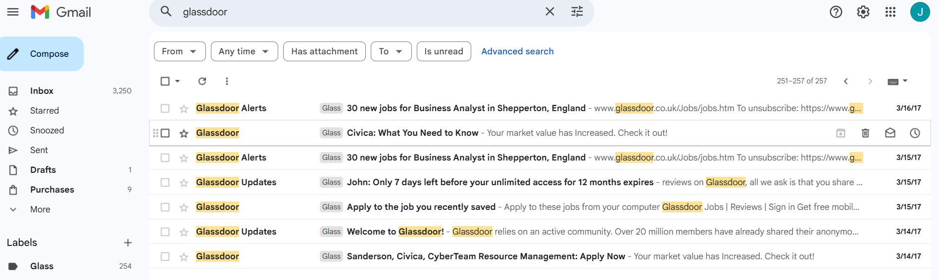

Figure 8: Showing Whizlabs Sender based on Search Bar. Explaining 257 vs 256 discrepancy
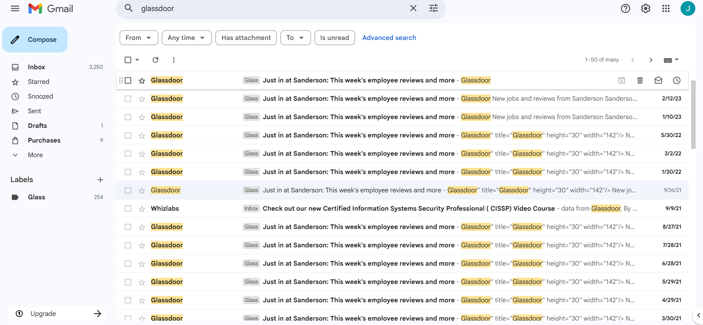

Figure 9: Labels Management, showing New Label and Delete for Reset.
